**POWER BI REPORT SERVER**

To design, host & secure **Interactive** Reports, **Paginated** Reports and **Mobile** Reports.

**Advantages of Power BI Report Server** : Secured, Local to your organization (**Intranet**)

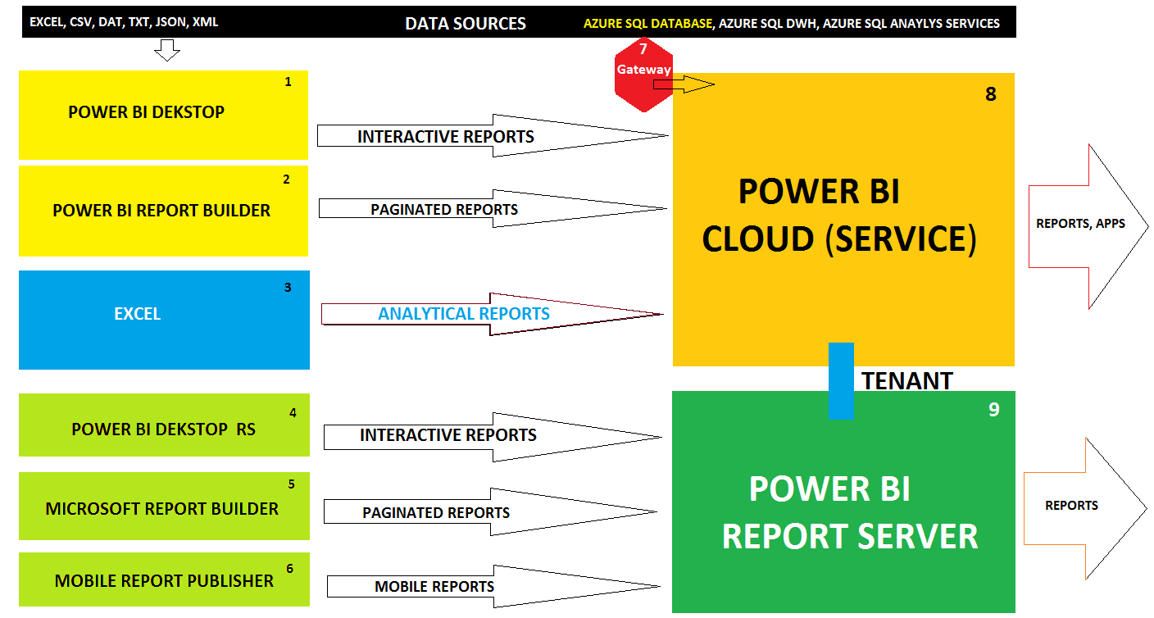

STEP 1: INSTALL **POWER BI DESKTOP RS** pbix, pbit

<https://www.microsoft.com/en-us/download/details.aspx?id=55330> <https://www.microsoft.com/en-us/download/confirmation.aspx?id=57271>

STEP 2: INSTALL **MICROSOFT** **REPORT BUILDER TOOL** rdl

<https://www.microsoft.com/en-us/download/confirmation.aspx?id=58158>

STEP 3: INSTALL **POWER BI MOBILE REPORT PUBLISHER** rsmobile

<https://www.microsoft.com/en-us/download/details.aspx?id=50400>

STEP 4: INSTALL **POWER BI REPORT SERVER**

STEP 1: INSTALL SQL SERVER 2017 or **2019** : <https://sqlschool.com/downloads/>

LAUNCH SSMS TOOL > TEST CONNECTION TO YOUR LOCAL SQL SERVER.

STEP 2: INSTALL POWER BI REPORT SERVER FROM : <https://aka.ms/pbireportserverexe>

AFTER INSTALLATION > **CONFIGURE** > "POWER BI REPORT SERVER CONFIGURATION" TOOL

CONNECT > LEFT : **DATABASE** PAGE > RIGHT : CHANGE DATABASE > SPECIFY SQL SERVER > NEXT > FINISH. **TWO** DATABASES ARE AUTO CREATED:

* **REPORT SERVER DATABASE** : TO STORE ACTUAL REPORTS [pbix, rdl, rsmobile]

* **REPORT SERVER TEMP DATABASE**: TO BE USED FOR TEMPORARY CACHING, TUNING

GO TO **WEB SERVICE URL** PAGE > CLICK @ APPLY. USED FOR END USER REPORT ACCESS.

GO TO **WEB PORTAL URL** PAGE > CLICK @ APPLY. USED FOR REPORT UPLOADS, MANAGEMENT

POWER BI SERVICE (CLOUD) > REGISTER > LOGIN TO POWER BI CLOUD **(TENANT). RESTART.**

GO TO **WEB SERVICE URL** > CLICK ON THE URL TO TEST IT.

GO TO **WEB PORTAL URL** > CLICK ON THE URL TO TEST IT.

----------------------------------

STEP 5: WINDOWS > APPS > SEARCH > **POWER BI DESKTOP** [RS]

FILE > OPEN > ANY EXISTING POWER BI REPORT > FILE > SAVE AS > SELECT REPORT SERVER.

SPECIFY 2ND URL ADDRESS: WEB PORTAL URL ADDRESS. SAVE.

THEN GO TO WEB PORTAL URL > REFRESH. WE SEE THE ABOVE INTERACTIVE REPORT.

STEP 6: WINDOWS > LAUNCH **REPORT BUILDER** > CHART WIZARD > CREATE A DATASET >

NEW DATA SOURCE > SELECT CONNECTION TYPE: AZURE SQL DATABASE > BUILD > SERVER,

DATABASE

**Server Name: sqlschoolprod.database.windows.net**

**Database Name: PRACTICEDATABASE**

**Authentication : Database (Option #2 [left] )**

**User Name: sql_school Password: zgrhi3216%$6**

EDIT AS TEXT > PASTE BELOW QUERY:

SELECT T.CalendarYear, T.CalendarQuarter,SUM(S.SalesAmount) AS TOTAL_SALES

FROM SALES_DATA AS S JOIN TIME_DATA AS T ON S.OrderDateKey = T.TimeKey

GROUP BY T.CalendarYear,T.CalendarQuarter

ARRANGE FILEDS INTO ROWS, COLUMNS AND SUMMARY VALUES > PREVIEW > FINISH.

GO TO POWER BI REPORT SERVER > PAGINATED REPORT > MANAGE > DATA SOURCES > SECURITY : OPTION #2 [CREDENTIALS STORED IN REPORT SERVER]

OPEN PAGINATED REPORT FROM POWER BI REPORT SERVER > CLICK @ POWER BI CLOUD SYMBOL > PIN THE POWER BI REPORT SERVER REPORTS TO POWER BI CLOUD

STEP 7: WINDOWS > LAUNCH **MOBILE REPORT PUBLISHER** >

SELECT TYPE OF REPORT LAYOUT:

1. MASTER *

2. TABLET

3. PHONE

SPECIFY 2 GRIDS WIDTH AND 2 GRIDS HEIGHT

SPECIFY COLOR PALLETE

SELECT REQUIRED REPORT ELEMENTS [EX: GAUGE, KPIs, FUNNEL, TREE MAP, ETC..]

DRAG n DROP EACH REPORT ELEMENT TO A GRID RESULTED FROM ABOVE LAYOUT.

ADD DATA FROM ONE OF THE BELOW SOURCES:

OPTION 1: EXCEL

OPTION 2: POWER BI REPORT SERVER

SELECT EACH REPORT ELEMENT > DEFINE THE VALUES & PROPERTIES

SETTINGS : REPORT NAME. CLIENT LEVEL CACHING FOR FASTER REPORTING

PREVIEW.

SAVE THE REPORT TO REPORT SERVER OR FILE SYSTEM [IN RSMOBILE FORMAT]

TO VERIFY THE MOBILE REPORT DEPLOYMENT:

GO TO POWER BI REPORT SERVER > WE SEE ABOVE MOBILE REPORT. CLICK TO VIEW.

STEP 7: TO PUBLISH DASHBOARDS FROM POWER BI REPORT SERVER :

STEP 1: ENSURE SQL SERVER AGENT IS STARTED

STEP 2: GO TO REPORT > MANAGE > DATA SOURCE > CUSTOM DATA SOURCE > OPTION #2: STORE CREDENTIALS IN THE REPORT SERVER > SPECIFY USER NAME AND PASSWORD >

TEST CONNECTION > APPLY > OK.

STEP 3: GO TO REPORT > SELECT REQUIRED TILE > CLICK @ PIN TO POWER BI BUTTON > LOG IN

TO POWER BI CLOUD (SERVICE) > SELECT WORKSPACE > SELECT DASHBOARD > PIN.

|  |  |  |
| --- | --- | --- |
| Feature | Power BI Cloud | Power BI Report Server |
| **Apps** | Supported | Not Supported |
| **Dashboards** | Supported | Not Supported |
| **Data Flows** | Supported | Not Supported |
| **Subscriptions** | Auto Enabled | Need additional SMTP |
| **Mobile Reports @ rsmobile** | Not Supported | Supported |
| **SQL Database for Report Store** | Not Supported | Supported |
| **Real-time Usage** | Public Projects, Web Apps | Private Projects, Secure |